Walk 50 Staunton-on-Wye
Last walked in January 2017

Description. A 7 Km (4.3 miles). Don’t do it when its wet underfoot as it crosses a number of arable fields. Pleasant walk with no hills.
Start. Staunton-on-Wye. Park at side of road near the school. Explorer Map 201 Grid 364450.
Directions from Whitecross Roundabout (Turn milometer to zero). Take the A438 Brecon road and after 8.6 miles you TR, signposted to Staunton-on-Wye. Ignore the first and second turnings to Staunton-on-Wye and take the third turning marked to ‘The New Inn’. Continue on for a couple of hundred yards and park on the L hand side of the road.

1. Staunton-on-Wye. At the second turning to Staunton-on-Wye is the War Memorial. It commemorates those who died in both world wars and has the names of those from Staunton-on-Wye who died in 1914 – 1919. Walk up the road, passing on your R the old primary school. Just before the road ends at a T-junction, and opposite a road on your R, you TL along a footpath that will soon leads onto the main road by a red telephone box. TL, walk a few paces along the road then TR onto a ‘no thru road’, signposted for Little London. Walk along the road and when it starts to bend to the L, by ‘Ivy Cottage’, you TR and walk along a bridleway. Continue along the enclosed grassy bridleway and just before reaching a black and white house on your L, you TL and cross over a stile. Walk straight across the newly planted orchard and then continue in the same direction, walking thru a more mature orchard along a wide opening between the trees. When you reach the end of the opening, at a T-junction where the trees are directly in front of you, TR and walk along the row of trees to the end of the field then TL and follow the field edge around.

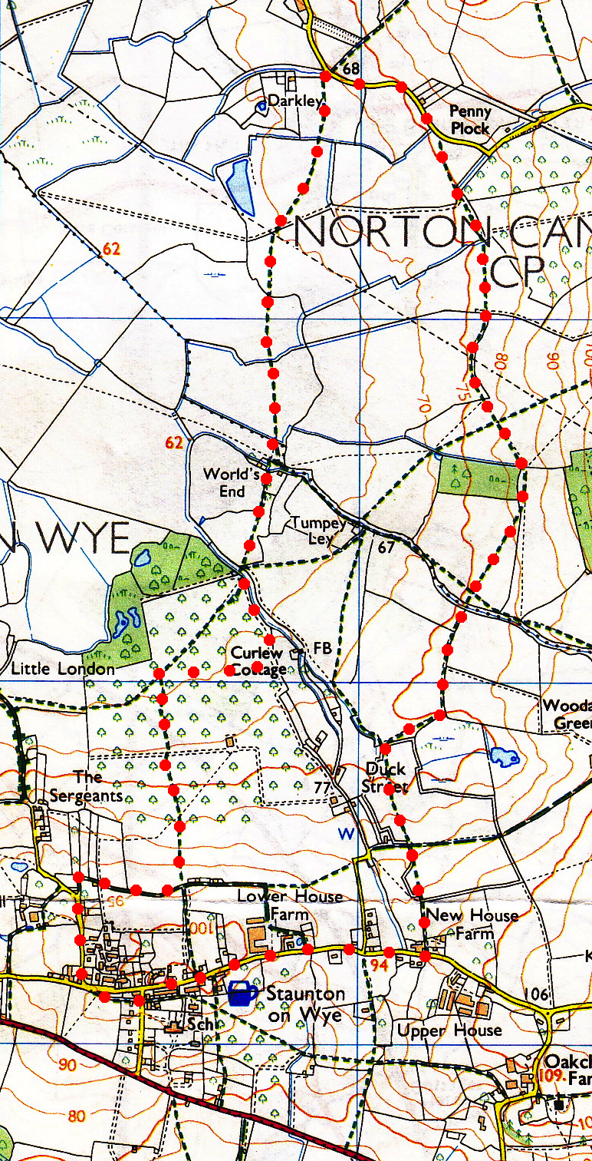
2. Way Marked Stile. On your R hand side at a corner of the field you TR and cross over a conduit (big pipe) that’s in the ditch and then follow the track round to your L. At the end of the track, (after about 30 meters and having passed a way marked wooden gate), you cross over another stile into a field {F1}. Cross over the open field and head for a red-bricked house, keeping R of a big oak tree. Continue in the same direction keeping to the hedge on your L and go thru a small wooden gate in the corner of the field and onto an enclosed track. Continue on to cross a footbridge and stile, then TR along a driveway, go over a cattle grid and TL to follow a public footpath over a metal gate into {F2}. Bear R, cross the field and go over another stile and footbridge into {F3}. Cross over an arable field, heading in the same direction towards two tall trees and a way marked sign in a gap in a hedge and into {F4}. Bear R (N) across another arable field to cross a hidden footbridge and stile into {F5}. The route is straight across this field, when you get to the other side cross over a stile onto a farm track. Cross the farm track and new fence into {F6}, (if a stile has not been put up then use the gate gap further up the track) and continue in the same direction, heading straight across this field to a cross a stile and footbridge into {F7}. Head across this field to a metal gate and stile onto a tarmac road where you TR and walk along the road.
3
3. House. Not far past a house on your L is a stile on your R, cross the stile into {F8}, and bearing slightly L go across the arable field, heading for an oak tree, to reach a wide farm track and two metal gates. Cross the farm track and continue in the same direction (south) into {F9}, where you keep to the hedge on your L until you cross a stile and footbridge into {F10}. Bear slightly R and continue straight across this field, heading for a gap in a hedge that is in the far corner of the field. Continue in the same direction, crossing the end of a farm track and into {F11}, where you keep to the hedge on your L. Continue on to the corner of the field and go thru the gap in the hedge into {F12}, where you head to the R of two big oak trees, and to the L hand corner of the wood in front of you where you cross a stile into {F13}. Continue south, keeping to the hedge on your R, and just past the woods you TR over a stile into {F14}. Bear L and cross over this field, cutting off the corner, and head towards the gap in the hedge to cross over a stile and a footbridge onto a partly tarmac track. Cross the track and go thru a metal gate into {F15} to continue in the same direction, keeping hedge to your L.
2
4

4. Two Fields. Continue on thru two fields {F16}{F17} keeping to the L edge. The second field bends R as you pass by a wooded area on your L, and when you reach the corner of the field, by a wooden gate and stile, go L over the stile. Go straight across a newly planted orchard, pass a house on your R and continue on towards five very tall trees. Cross a stile on the R of the five very tall trees and continue along the hedge on your R, cross over another stile and then go thru a tall wooden garden gate onto a drive. Go along the drive to reach the main road. TR and continue along the road for about ¾ km and thru Staunton-on-Wye where you TL onto the road you have parked your car.
1

